Capstone Project Proposal

GitHub Repository Link: https://github.com/sba25055-maker/CA-Capstone-Project-sba25055

Capstone Project Proposal 1
1. Project Title 2
Predictive Demand Analysis in Irish Tourist Accommodation: A Binary Classification Approach to Occupancy Optimization and Commercial Profitability 2
2. Introduction 2
3. Problem Definition 2
4. Aim and Objectives 3
Overall Aim 3
Business Hypothesis 3
Specific Objectives 3
5. Scope 4
6. Methodology 5
7. Data Sources 5
8. Expected Deliverables 6
10. Ethical and Legal Considerations 7
Data Protection and Privacy (GDPR) 7
Data Security and Potential Bias 7
Word Count: 1574 8
References: 8

1. Project Title

Predictive Demand Analysis in Irish Tourist Accommodation: A Binary Classification Approach to Occupancy Optimization and Commercial Profitability

2. Introduction
The short-term rental market in the Republic of Ireland has changed considerably in recent years, driven by international tourism, economic growth, and changing traveller preferences (Guttentag, 2019),. Although these developments have created opportunities for property owners and Property Management Companies (PMCs), increasing competition has made maintaining occupancy and profitability more challenging. Many managers still rely on personal experience, historical habits, and observations when setting prices and managing availability, rather than using systematic data analysis.
This project proposes a predictive analytics system to support better decision-making within Ireland's tourist accommodation sector. By examining historical property availability, geographical location, and individual property characteristics, the research will identify patterns that may help predict future demand. An unbooked night represents lost revenue that cannot be recovered once the date has passed, making effective occupancy management essential.
The project will demonstrate how information technology and predictive analytics can help property managers move away from reactive decisions towards a more proactive, evidence-based approach. Ultimately, the research aims to improve operational planning, strengthen competitiveness, and support commercial profitability.

3. Problem Definition
The main business problem addressed by this project is the difficulty of predicting whether a tourist property will be booked on a particular date. Without reliable information about future demand, property managers risk making decisions that negatively affect revenue and resource allocation.
Two major challenges arise from this uncertainty.
- Revenue losses from overestimating demand: When managers incorrectly assume that demand will be high, unsuitable pricing and availability decisions can leave properties vacant. This reduces income, affects cash flow, and lowers the return on investment (ROI) of the property.
- Missed opportunities from underestimating demand: When managers fail to recognise periods of high demand or differences between market segments, they may miss opportunities to adjust marketing activities, minimum-stay requirements, and operational plans in advance.
Predictive analytics offers a practical way to address these challenges through binary classification (Čumlievski, Brkić Bakarić and Matetić, 2022). Instead of forecasting a continuous variable, the project will classify property calendar status into two categories: Rented (high demand) and Vacant (low demand).
Historical records will be analysed to identify relationships between geographical location, property amenities, seasonality, and availability. These patterns could help property managers anticipate demand more effectively and make informed commercial decisions. Calendar availability will be treated as an indicator of demand, rather than definitive evidence that a booking has been completed.

4. Aim and Objectives

Overall Aim
The primary aim is to develop, evaluate, and implement a predictive classification model that estimates the availability status of tourist accommodation in Ireland. The resulting insights will help property managers improve occupancy planning and make better-informed commercial decisions.

Business Hypothesis
The project hypothesises that geographical characteristics, property features, and seasonal factors significantly influence accommodation demand (Cervera, D. de J., de Esteban Curiel, J. and Pérez-Bustamante Yábar, D.C. (2024). Variables such as neighbourhood, region, guest capacity, amenities, month, and day of the week may reveal patterns that are difficult to identify through manual observation.
By applying classification algorithms to historical data, the research aims to identify these relationships and use them to support more effective operational planning.

Specific Objectives
- Data Consolidation: Collect, clean, and prepare property inventory and calendar datasets, ensuring consistency and reliability.
- Exploratory Data Analysis (EDA): Identify geographical, seasonal, and property-related patterns associated with historical availability.
- Feature Engineering: Transform categorical and temporal variables into suitable formats for machine learning.
- Predictive Model Development: Implement and compare several binary classification algorithms to identify the most suitable approach.
- Business Intelligence Development: Create an interactive dashboard that presents model predictions and analytical findings in a format useful to property managers.
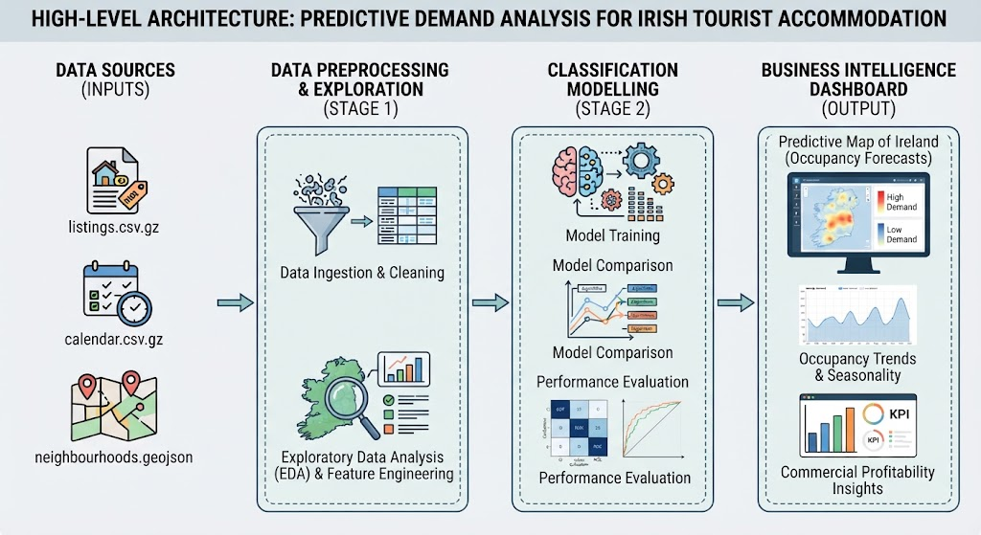

5. Scope
The project will be completed across two academic semesters. Clear boundaries will help keep the research manageable while allowing sufficient technical and analytical depth.
- Geographical Coverage: The research will focus exclusively on the Republic of Ireland.
- Data Sources: Static historical datasets from open-source platforms will be used, with analysis conducted through batch processing.
- Predictive Modelling: Semester 2 will focus on binary classification using daily property calendar availability as the target variable.
- Geospatial Analysis: Property information will be combined with geographical data, including polygon shapefiles and GeoJSON files, to support mapping and regional analysis.
Out of Scope
- Real-Time Processing: Live web scraping and continuous commercial API access will be excluded because of infrastructure and licensing constraints.
- Textual Analytics: Natural Language Processing (NLP) and sentiment analysis of guest reviews will not be included. This will allow the project to concentrate on numerical and categorical variables.
These boundaries provide a realistic foundation for completing the research within the academic year.

6. Methodology
The project will follow the CRISP-DM framework, which provides a structured approach to data analysis (Chapman et al., 2000) while keeping the research aligned with its business objectives. Python will be the primary programming language, supported by appropriate data analysis and machine learning libraries (Pedregosa et al., 2011).
The initial stage will involve data collection and preparation. Exploratory Data Analysis techniques will address missing values, inconsistent boolean variables, and differences in date formats. The datasets will then be checked for quality and consistency before further analysis.
Exploratory Data Analysis will investigate relationships between property characteristics, geographical distribution, and calendar availability. Statistical summaries and visualisations will help identify regional differences, seasonal patterns, and characteristics associated with higher or lower availability.
The modelling stage will use supervised binary classification. The prepared dataset will be divided into training and testing subsets, allowing algorithms to learn from historical examples and be evaluated using previously unseen records. Short-term rental repositories comprise heterogeneous data combining numerical attributes, categorical variables, and complex spatial interactions requiring structured pre-processing pipelines (Nkomo, 2026).
Input variables will include guest capacity, property type, and geographical location. The target variable will classify each property's daily status as Available or Unavailable. These categories will be used to investigate demand patterns, recognising that availability does not necessarily confirm whether a booking occurred.
Several classification algorithms will be implemented and compared. Performance will be assessed using a confusion matrix, precision, recall, and F1-score. These measures will help identify classification errors and determine which model provides the most suitable results for the intended business application.

7. Data Sources
The project will use Inside Airbnb ,Get the data. (2026), an independent repository that provides publicly accessible short-term rental market datasets. Three files will form the basis of the research.
- listings.csv.gz: Contains property information, including geographical coordinates, property types, guest capacity, beds, bathrooms, and historical review metrics. These variables will support exploratory analysis and feature engineering.
- calendar.csv.gz: Contains dated availability records for individual properties. This dataset will provide the target information needed to classify daily availability.
- neighbourhoods.geojson: Provides geographical boundaries for neighbourhoods and districts. It will support mapping, spatial visualisation, and regional analysis during Semester 1.
These datasets will provide a substantial foundation for examining accommodation patterns across Ireland. Before analysis begins, the applicable licences and permitted uses will be checked to ensure compliance with relevant academic and legal requirements.

8. Expected Deliverables
By the end of Semester 2, the project is expected to produce four main deliverables.
- Master Data Repository: A centralised, cleaned, and documented dataset prepared for machine learning, with appropriate data quality checks.
- Strategic Analytical Report: A report presenting visual findings on geographical distributions, seasonal patterns, and historical availability across Ireland.
- Predictive Classification Pipeline: Documented Python code in Jupyter Notebooks covering model training, testing, validation, and performance evaluation.
- Business Intelligence Dashboard: An interactive interface allowing stakeholders to explore property characteristics, examine availability patterns, and review model predictions.
Together, these deliverables will demonstrate how historical data can be converted into practical information for property management and commercial planning
9. Project Timeline
The project will progress through six phases across the two academic semesters.
- Phase 1: Setup and Proposal (October 2026): Define the business problem, establish the research scope, complete the initial ethical review, and submit the architectural proposal (CA1).
- Phase 2: Data Ingestion and Cleaning (November 2026): Extract the datasets, correct inconsistencies, standardise variables, and consolidate the information.
- Phase 3: Exploration and Discovery (December 2026–January 2027): Conduct EDA, create geographical visualisations, investigate seasonal trends, and present Semester 1 findings.
- Phase 4: Transformation and Modelling (February–March 2027): Complete feature engineering, encode temporal variables, and train and compare classification algorithms.
- Phase 5: Commercial Validation (April 2027): Evaluate model performance on unseen data, assess reliability, and examine generalisation.
- Phase 6: Deployment and Conclusion (May 2027): Finalise the dashboard and technical documentation, consolidate findings, and prepare for the Capstone project defence.
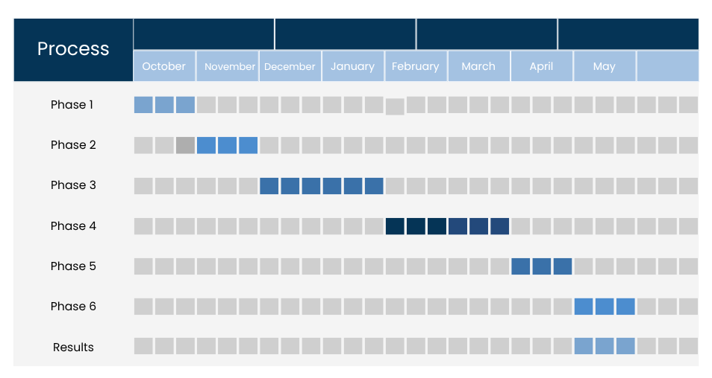

10. Ethical and Legal Considerations

Data Protection and Privacy (GDPR)
Inside Airbnb datasets use identifiers and generally exclude sensitive information such as banking details, full host names, and individual guest transaction histories. The research will focus on property characteristics, geographical information, and calendar availability rather than identifying individuals aligning with broader ethical standards in open data research (Kitchin, 2014).
The applicable dataset licences and data protection requirements will be reviewed to ensure that the proposed research complies with relevant General Data Protection Regulation (GDPR) obligations.

Data Security and Potential Bias
All datasets will be stored in encrypted local storage or appropriately secured private cloud repositories. Access will be restricted to authorised project personnel to reduce the risk of unauthorised access or data loss.
The model's predictions will also be reviewed for potential geographical and commercial bias. Historical data may reflect existing differences between districts, so findings must be interpreted carefully. This review will help ensure that recommendations remain fair and are supported by the available evidence.
Formal ethical compliance will be documented through the signed Institutional Ethics Form submitted alongside the project proposal.

Word Count: 1574

References:

- Guttentag, D. (2019). Progress on airbnb: A literature review. [online] ResearchGate. Available at: https://www.researchgate.net/publication/333880155_Progress_on_Airbnb_a_literature_review [Accessed 9 Oct. 2026]
- Cervera, D. de J., de Esteban Curiel, J. and Pérez-Bustamante Yábar, D.C. (2024). Machine Learning for short-term property rental pricing based on seasonality and proximity to food establishments. British Food Journal, 126(13), pp.332–352. doi:10.1108/bfj-07-2023-0634
- Čumlievski, N., Brkić Bakarić, M. and Matetić, M. (2022). A smart tourism case study: Classification of accommodation using machine learning models based on accommodation characteristics and online guest reviews. Electronics, 11(6), p.913. doi:10.3390/electronics11060913
- Chapman, P., Clinton, J., Kerber, R., Khabaza, T., Reinartz, T.P., Shearer, C. and Wirth, R. (2000). CRISP-DM 1.0: Step-by-step data mining guide. [online] Available at: https://www.semanticscholar.org/paper/54bad20bbc7938991bf34f86dde0babfbd2d5a72 [Accessed 11 Oct. 2026].
- Pedregosa, F., Pedregosa@inria, F., Fr, Org, G., Michel, V., Fr, B., Grisel, O., Grisel@ensta, O., Blondel, M., Prettenhofer, P., Weiss, R., Com, V., Vanderplas, J., Com, A., Cournapeau, D., Varoquaux, G., Gramfort, A., Thirion, B., Dubourg, V., Passos, A., Brucher, M., Perrot Andédouard Duchesnay, M., Fŕ, M. and Duchesnay@cea, E. (2011). Scikit-learn: Machine learning in Python Gaël Varoquaux Bertrand Thirion Vincent Dubourg Alexandre Passos Pedregosa, Varoquaux, Gramfort et al. Matthieu Perrot Edouard Duchesnay. Journal of Machine Learning Research, [online] 12, pp.2825–2830. Available at: https://jmlr.org/papers/volume12/pedregosa11a/pedregosa11a.pdf [Accessed 11 Oct. 2026].

- Nkomo, S. A., Ahmadi, E., & Maihami, R. (2026). Identifying key attributes associated with short-term rental occupancy rates: Case of Airbnb. Forecasting, 8(4), 60. https://doi.org/10.3390/forecast8040060
- Kitchin, R. (2014). Big data, new epistemologies and paradigm shifts. Big Data & Society, 1(1), pp.1–12. doi:10.1177/2053951714528481.
- Get the data. (2026). Insideairbnb.Com. https://insideairbnb.com/es/get-the-data/

